TEAM ID: LTVIP2026TMIDS41940
RESOLVENOW: YOUR PLATFORM FOR ONLINE COMPLAINTS
1. INTRODUCTION
1.1 Project Overview
Project Title: ResolveNow – Your Platform for Online Complaints
Team ID: LTVIP2026TMIDS41940
Team Members:
Nellore Lakshmi Prasanna - Team Leader
Jadi Lathish - Team Member
Sunkara Sathish -Team Member
Shaik Ezaz Ahmed – Team Member
Project Description
ResolveNow is a web-based complaint management system designed to provide a transparent, structured, and efficient platform for users to register and track complaints online. The system allows users to submit complaints related to public services such as electricity, water, roads, sanitation, and other civic issues.
The platform ensures secure authentication, complaint categorization, real-time tracking, and administrative resolution handling through a centralized dashboard.

Scenario 1: Registering a Civic Complaint
A citizen observes a damaged road in their area. Using ResolveNow, they log in, submit a complaint with category and description, and receive a tracking ID for monitoring resolution status.
Scenario 2: Tracking Complaint Status
A user checks the complaint status online and sees that the issue has moved from “Pending” to “In Progress”.
Scenario 3: Administrative Resolution
An admin reviews complaints, assigns priority, updates status, and marks it as “Resolved” after verification.

1.2 Purpose
The primary purpose of ResolveNow is to digitize and streamline the complaint registration and resolution process.
Key Objectives:
- To provide a centralized complaint submission platform
- To enable real-time complaint tracking
- To improve transparency in resolution process
- To reduce manual paperwork
- To maintain structured complaint records

2. IDEATION PHASE
2.1 Customer Problem Statement
Many citizens face difficulty in registering complaints through traditional systems due to:
- Lack of transparency
- No tracking mechanism
- Delayed response
- Manual paperwork
Users feel frustrated when complaints are ignored or not updated properly.

Problem Statement Table
Problem Statement | Customer | Trying To | But | Because | Feel
PS-1 | A citizen | Register a complaint | No proper tracking | Manual system | Frustrated
PS-2 | A resident | Track issue status | No updates provided | Poor communication | Helpless
PS-3 | Admin | Manage complaints efficiently | Data scattered | No centralized system | Overwhelmed

2.2 Empathy Map Canvas
Empathy mapping helped understand user pain points such as:
- Need for faster complaint handling
- Transparency in status
- Simple user interface
- Trust in resolution process

2.3 Brainstorming
Step 1: Identify complaint management issues
Step 2: Generate ideas (Tracking ID, Status updates, Dashboard)
Step 3: Prioritize features (Login, Submit Complaint, Admin Panel)

3. REQUIREMENT ANALYSIS
3.1 Functional Requirements
FR No | Functional Requirement | Description
FR-1 | User Registration | User can create account
FR-2 | User Login | Secure authentication
FR-3 | Complaint Submission | Submit complaint with category
FR-4 | Complaint Tracking | Track complaint using ID
FR-5 | Admin Dashboard | Admin can view all complaints
FR-6 | Status Update | Admin updates complaint status
FR-7 | Report Generation | Generate complaint reports

Non-Functional Requirements
NFR No | Requirement | Description
NFR-1 | Security | Secure login and data protection
NFR-2 | Performance | Fast response time
NFR-3 | Reliability | System works consistently
NFR-4 | Scalability | Supports increasing users
NFR-5 | Usability | Simple and user-friendly UI

3.2 User Story Table
User | Story | Acceptance Criteria | Priority
User | Register account | Account created successfully | High
User | Submit complaint | Complaint saved in database | High
User | Track complaint | Status displayed correctly | High
Admin | View complaints | All complaints visible | High
Admin | Update status | Status updated in system | High

3.3 Technology Stack
Component | Technology
Frontend | React / HTML, CSS, JS
Backend | Node.js / Flask
Database | MongoDB / MySQL
Authentication | JWT
Hosting | Localhost / Cloud

4. PROJECT DESIGN
4.1 Problem Solution Fit
ResolveNow solves transparency and tracking problems by providing a centralized digital complaint system.

4.2 Proposed Solution
ResolveNow is a role-based complaint management web application that allows:
- Users to submit complaints
- Admin to manage and resolve complaints
- Real-time status updates
- Centralized database storage

4.3 Solution Architecture
User → Frontend → Backend API → Database
Admin → Dashboard → Update Status → Database
Three-tier architecture:
- Presentation Layer
- Business Logic Layer
- Data Layer

5. PROJECT PLANNING & SCHEDULING
Sprint Plan
Sprint | Task | Duration
Sprint 1 | UI Development | 1 Week
Sprint 2 | Backend & Database | 1 Week
Sprint 3 | Integration & Testing | 1 Week
Velocity: 20 Story Points per Sprint

6. FUNCTIONAL AND PERFORMANCE TESTING
Test Cases
Test Case | Expected Result | Status
User Registration | Account created | Pass
Complaint Submission | Stored in DB | Pass
Status Update | Updated correctly | Pass
Login Security | Invalid login rejected | Pass

7. RESULTS
Step 1: Run backend server
Step 2: Open frontend in browser
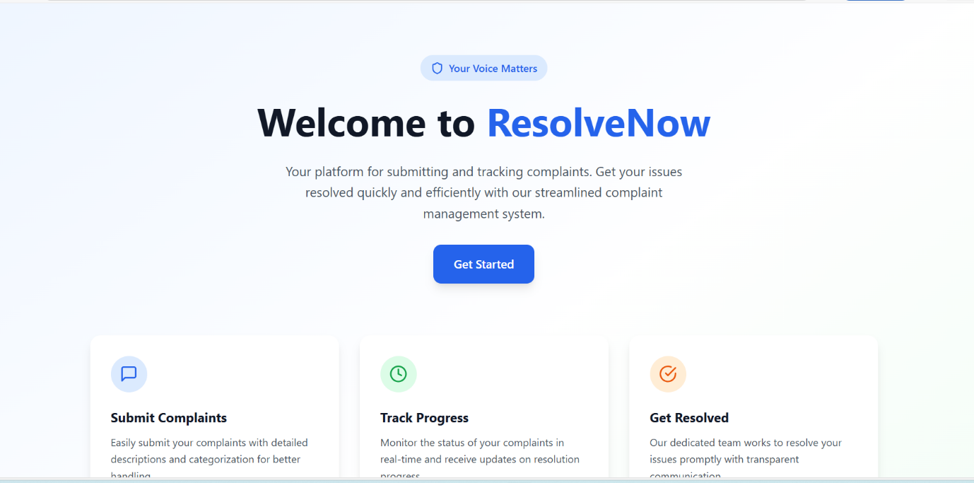
Step 3: Register/Login
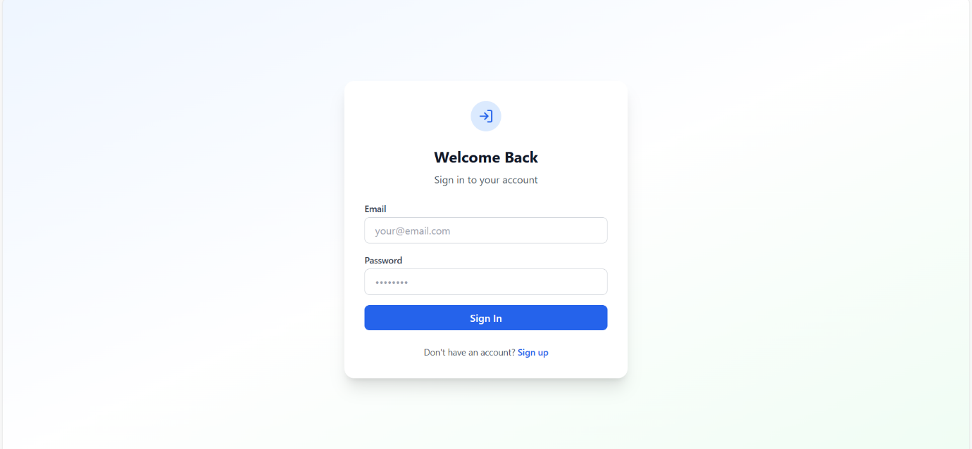
Step 4: Submit complaint
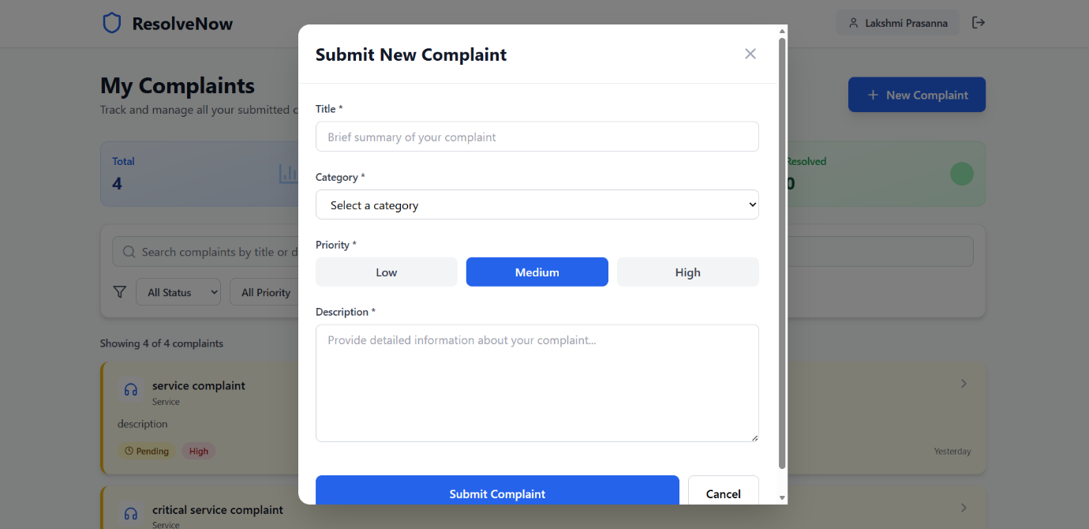
Step 5: Admin updates status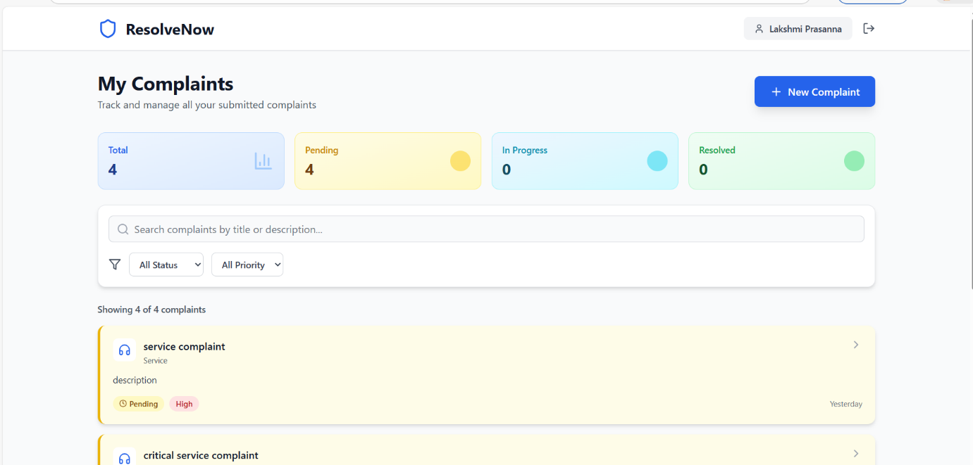
Step 6: User tracks complaint

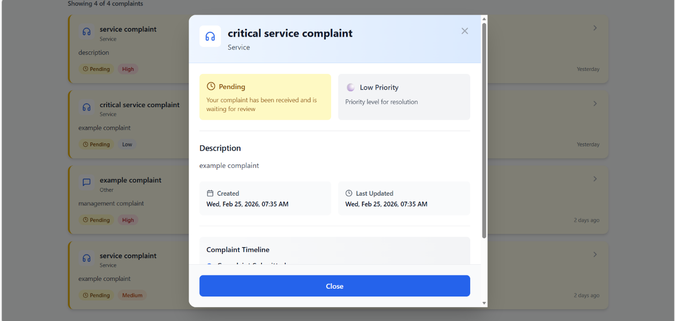

8. ADVANTAGES & DISADVANTAGES
Advantages
- Transparent system
- Centralized complaint tracking
- Faster resolution
- Secure authentication
Disadvantages
- Requires internet access
- Admin workload increases with user growth
- Depends on server uptime

9. CONCLUSION
ResolveNow successfully digitizes complaint management and improves transparency, efficiency, and user trust. The system demonstrates structured architecture, role-based access, and scalable deployment capability.

10. FUTURE SCOPE
- AI-based complaint severity prediction
- Mobile application
- Email/SMS notification system
- Analytics dashboard
- Government portal integration
Github Link :
https://github.com/Lakshmi-1234567/ResolveNow-Your-Platform-for-Online-Complaints.git
Demo Video Link :
https://drive.google.com/file/d/1xCMW7J3IHn5T2f4QLGPgUxuJwtMxzIb/view?usp=drive_link

